TEST PLAN & RTM

Module Name: E-Commerce Website - Login Module Test Case
Test Case ID: TC001 - TC012
Tester Name: Chouhan Himansu Raj Singh

Test Scenarios :
Scenario ID: 1a
Scenario: Login with valid username and password
Test Steps:
1. Open the E-Commerce Website login page
2. Enter Username
3. Enter Password
4. Click Login Button
Screenshots: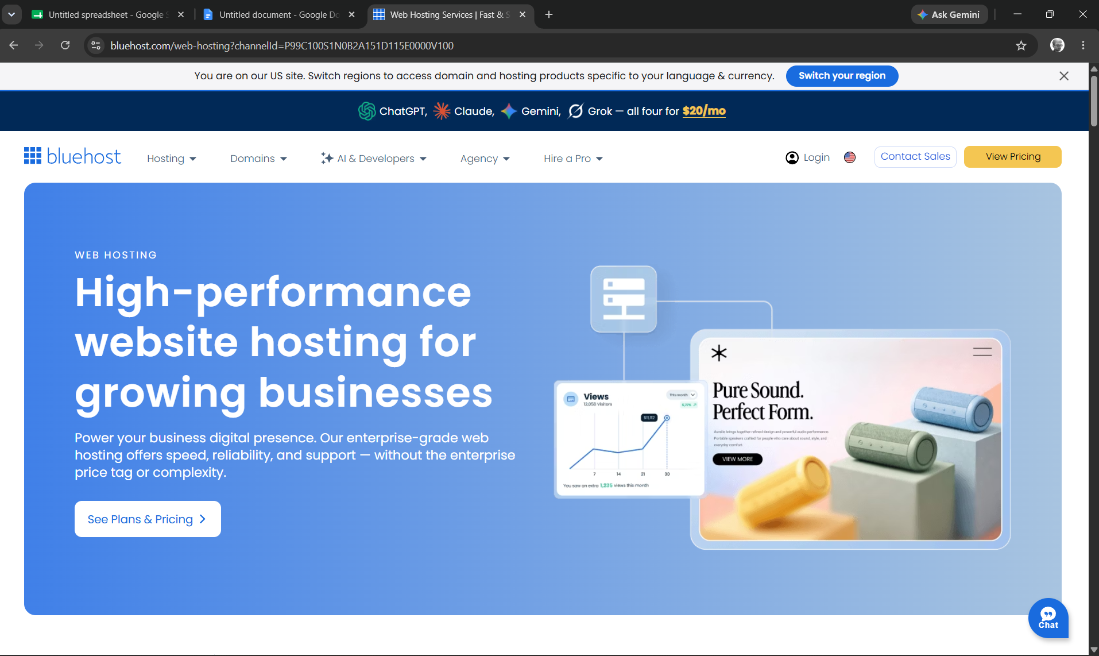

Scenario ID: 1b
Scenario: Login with valid username, incorrect password
Test Steps:
1. Open the E-Commerce Website login page
2. Enter Username
3. Enter Password
4. Click Login Button
Screenshots:
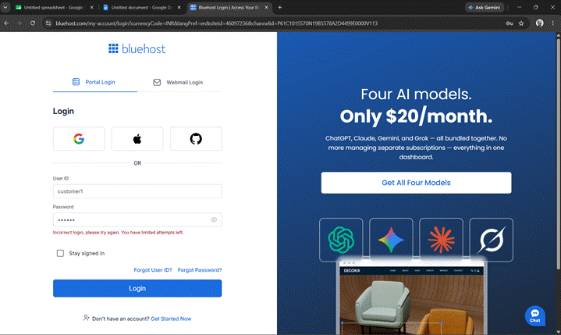

Scenario ID: 1c
Scenario: Login with invalid username, valid password
Test Steps:
1. Open the E-Commerce Website login page
2. Enter Username
3. Enter Password
4. Click Login Button
Screenshots: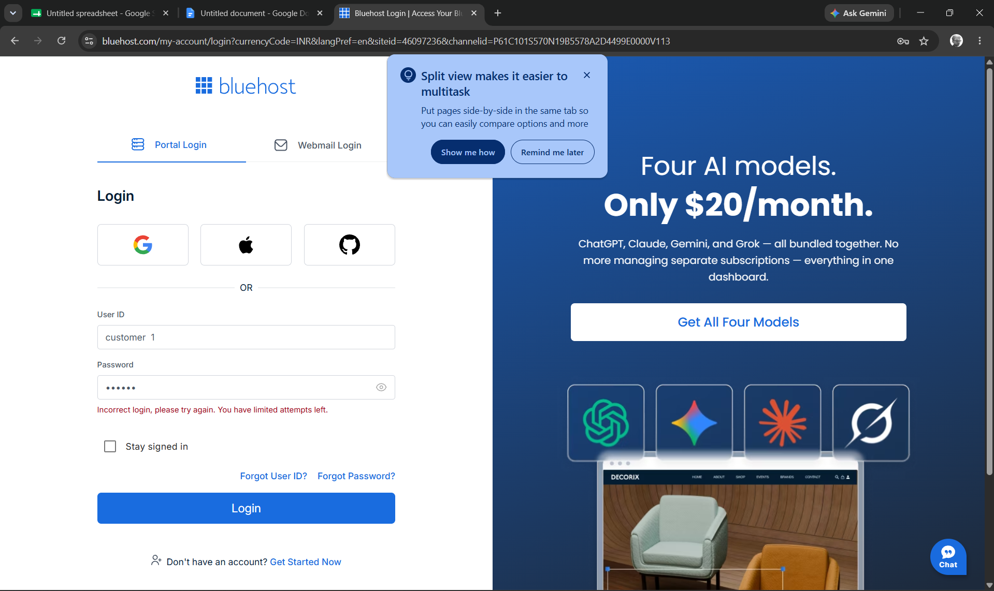
Scenario ID: 1d
Scenario: Login with invalid username and invalid password
Test Steps:
1. Open the E-Commerce Website login page
2. Enter Username
3. Enter Password
4. Click Login Button
Screenshots: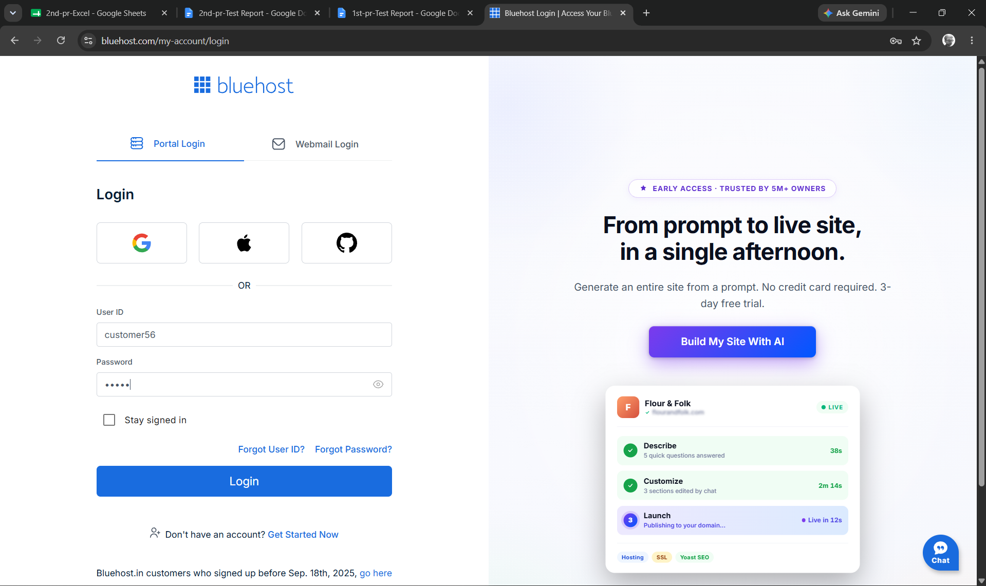

Scenario ID: 1e
Scenario: Login with blank username, valid password
Test Steps:
1. Open the E-Commerce Website login page
2. Enter Username
3. Enter Password
4. Click Login Button
Screenshots: 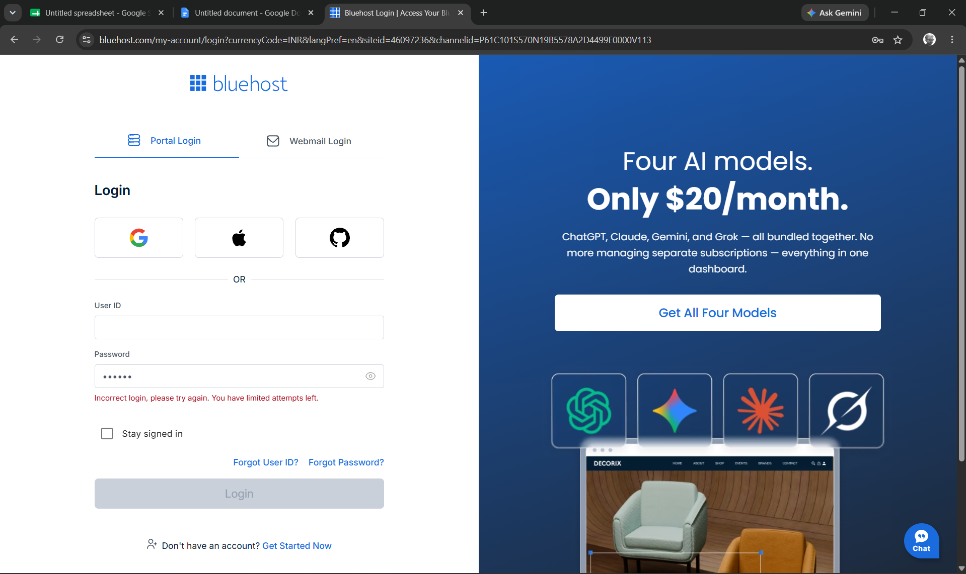

Scenario ID: 1f
Scenario: Login with valid username, blank password
Test Steps:
1. Open the E-Commerce Website login page
2. Enter Username
3. Enter Password
4. Click Login Button

Screenshots:
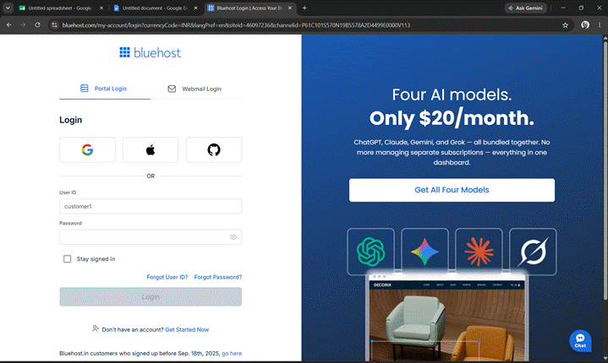
Scenario ID: 1g
Scenario: Login with valid username containing extra spaces
Test Steps:
1. Open the E-Commerce Website login page
2. Enter Username
3. Enter Password
4. Click Login Button
Screenshots:
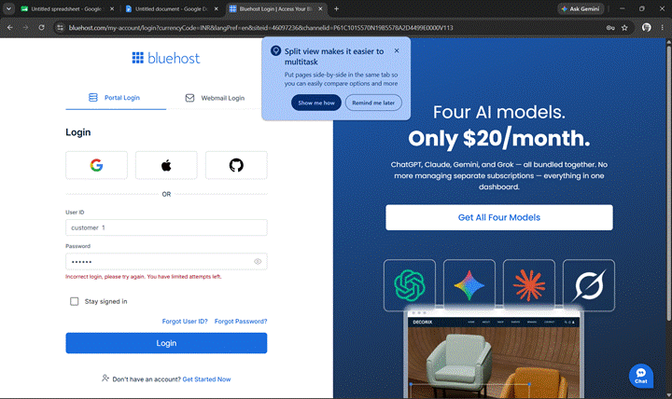

Scenario ID: 1h
Scenario: Login with correct username but wrong password case
Test Steps:
1. Open the E-Commerce Website login page
2. Enter Username
3. Enter Password
4. Click Login Button
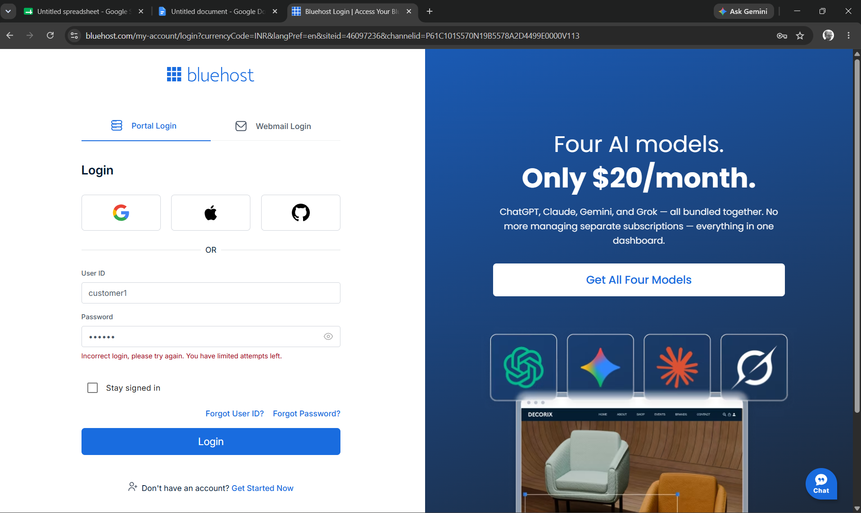

Scenario ID: 1i
Scenario: Verify error message display on invalid login
Test Steps:
1. Open the E-Commerce Website login page
2. Enter Username
3. Enter Password
4. Click Login Button

Screenshots:
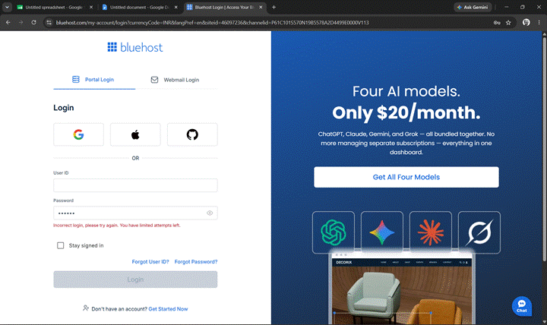
Scenario ID: 1j
Scenario: Verify redirection to shopping homepage after successful login
Test Steps:
1. Open the E-Commerce Website login page
2. Enter Username
3. Enter Password
4. Click Login Button
Screenshots:
Scenario ID: 1k
Scenario: Lock account after 3 consecutive failed login attempts
Test Steps:
1. Open the E-Commerce Website login page
2. Enter Username
3. Enter Password
4. Click Login Button
Screenshots:
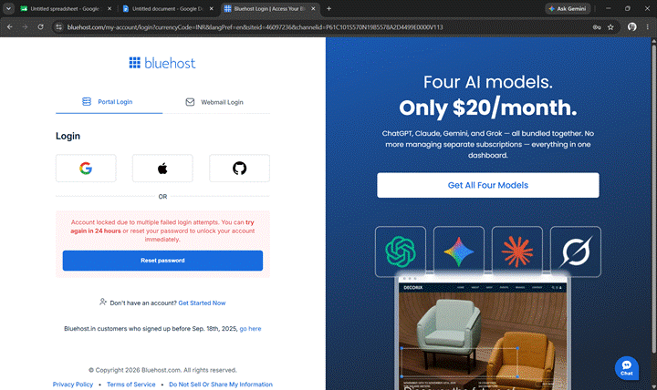

Scenario ID: 1l
Scenario: Logout and verify return to login page
Test Steps:
1. Open the E-Commerce Website login page
2. Enter Username
3. Enter Password
4. Click Login Button
Screenshots:

Summary of Test Results:
Total Test Cases : 12
Passed : 12
Failed : 0
Not Executed : 0
Pass Rate (%) : 100%
Conclusion and Recommendations
Conclusion
Out of 12 test scenarios executed for the E-Commerce Website Login Module, 12 passed and 0 failed, giving a pass rate of 100%. Core authentication behaviour - valid login, rejection of invalid credentials, blank-field validation, input trimming, case sensitivity, error messaging, and post-login redirection and logout - all worked as expected.
Test Coverage Analysis
● Valid credential authentication - PASSED
● Invalid credential rejection - PASSED
● Blank field validation - PASSED
● Input trimming/space handling - PASSED
● Password case sensitivity - PASSED
● Error message accuracy - PASSED
● Redirection to homepage after login - PASSED
● Account lockout after failed attempts - PASSED
● Logout / session termination - PASSED

Recommendations
• The Login Module is ready for deployment to production with the current functionality.
• Consider implementing additional security features such as rate limiting, account lockout after failed attempts, and CAPTCHA for enhanced protection.
• Add password encryption/hashing to ensure credentials are stored securely.
• Implement session timeout and secure session management protocols.
• Perform penetration testing to identify potential security vulnerabilities.
• Add logging and monitoring for login attempts for audit and security compliance.
• Test with additional scenarios including SQL injection attempts, XSS attacks, and brute force attempts.
• Conduct performance testing under load to ensure the login module scales appropriately.
• Implement two-factor authentication (2FA) for enhanced security.
• Regular security updates and maintenance should be scheduled.

Bug Reports
Summary: No bugs identified during the execution of the 7 test scenarios. All tests passed with expected results matching actual results.

